MUHAMMAD AHMAD RAZA
Digital Marketer

 A B O U T M E
Motivated Digital Marketing professional and Computer Science student at CUVAS Bahawalpur. Skilled in Digital Marketing, Social Media Management, Meta Ads, Shopify Listing, and Data Entry. Strong communication and management abilities with a passion for business growth and online marketing. Committed to continuous learning and professional development.

 E X P E R I E N C E

Digital Marketing Executive

Apex Digital Grow
2025 – 2026

Managed digital marketing campaigns and social media accounts for clients. Planned and optimized Meta Ads campaigns to increase brand awareness, customer engagement, and lead generation. Assisted in developing marketing strategies that supported business growth and online visibility.

Social Media Manager

Apex Digital Grow
2025 – 2026

Created and scheduled content across social media platforms while monitoring audience engagement. Worked on growing brand presence, responding to customer interactions, and maintaining consistent communication with target audiences.

Shopify Listing Specialist

Apex Digital Grow
2025 – 2026

Handled Shopify product listings, product descriptions, inventory updates, and store management tasks. Ensured accurate product information and maintained organized e-commerce records to improve store performance and customer experience.

Data Entry & Administrative Assistant

Apex Digital Grow
2025 – 2026

Maintained business records and performed data entry tasks with accuracy and attention to detail. Assisted in report preparation, database management, and administrative support to ensure smooth daily operations.

 R E F E R E N C E
Adil Hassan

Senior Manager



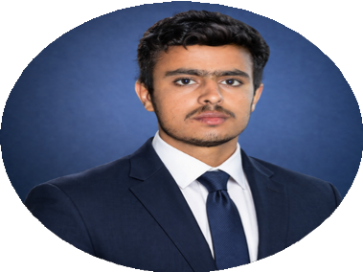
Phone: Email :
C O N T A C T
03200623818
ahmadrazasial536@gmail.com Lodhra
E D U C A T I O N

Punjab College Lodhran
Fsc Pre Medical
2022 - 2024

CUVAS Bahawalpur
Bachelor of Computer Science
2024 - 2028
S K I L L S
Management Skills Digital Marketing Shopify Listing Data Entry
Social Media Management
Meta Adds
L A N G U A G E
English Urdu
0319 6438726
hasssad0980@gmail.com

